CART.HTML PAGE 1

<!DOCTYPE html>
<html lang="en">
<head>
<meta charset="UTF-8">
<meta name="viewport" content="width=device-width, initial-scale=1.0">
<title>Thread & Trend | Cart</title>
<link rel="stylesheet" href="style.css">
<script src="script.js" defer></script>
</head>
<body data-page="cart">
<header class="site-header">
<a class="logo" href="index.html">Thread<span>&</span>Trend</a>
<nav class="main-nav">
<a href="index.html">Home</a><a href="shop.html">Shop</a><a href="wishlist.html">Wishlist <span class="nav-count" id="wishlistCount">0</span></a><a class="active" href="cart.html">Cart <span class="nav-count" id="cartCount">0</span></a><a href="login.html">Login</a>
</nav>
</header>

<main class="section-wrap">
<div class="page-heading"><p class="eyebrow">READY WHEN YOU ARE</p><h1>Your shopping cart</h1><p>Check your items before you place your order.</p></div>
<div class="cart-layout">
<section id="cartItems" class="cart-items"></section>
<aside class="summary-card">
<h2>Order summary</h2>
<form id="couponForm" class="coupon-form"><label for="couponCode">Coupon code</label><div class="coupon-row"><input id="couponCode" type="text" placeholder="Enter SAVE10"><button class="button button-dark" type="submit">Apply</button></div><p id="couponMessage" class="form-message"></p></form>
<div class="summary-line"><span>Subtotal</span><strong id="subtotalValue">₹0</strong></div>
<div class="summary-line"><span>Discount</span><strong id="discountValue">₹0</strong></div>
<div class="summary-line"><span>GST (5%)</span><strong id="gstValue">₹0</strong></div>
<div class="summary-line total-line"><span>Total</span><strong id="totalValue">₹0</strong></div>
<a class="button checkout-button" id="checkoutLink" href="checkout.html">Proceed to checkout</a>
<a class="continue-link" href="shop.html">← Continue shopping</a>
</aside>
</div>
</main>

<footer class="site-footer"><p>© 2026 Thread & Trend. Student project demo.</p><p><a href="shop.html">Shop more</a></p></footer>
</body>
</html>

CHECKOUT.HTML

<!DOCTYPE html>
<html lang="en">
<head>
<meta charset="UTF-8">
<meta name="viewport" content="width=device-width, initial-scale=1.0">
<title>Thread & Trend | Checkout</title>
<link rel="stylesheet" href="style.css">
<script src="script.js" defer></script>
</head>
<body data-page="checkout">
<header class="site-header">
<a class="logo" href="index.html">Thread<span>&</span>Trend</a>
<nav class="main-nav">
<a href="index.html">Home</a><a href="shop.html">Shop</a><a href="wishlist.html">Wishlist <span class="nav-count" id="wishlistCount">0</span></a><a href="cart.html">Cart <span class="nav-count" id="cartCount">0</span></a><a href="login.html">Login</a>
</nav>
</header>

<main class="section-wrap narrow-wrap">
<div class="page-heading"><p class="eyebrow">ALMOST THERE</p><h1>Checkout</h1><p>Enter your delivery details to place your demo order.</p></div>
<div class="checkout-card">
<form id="checkoutForm" novalidate>
<div class="form-grid">
<div class="form-field full-width"><label for="fullName">Full name</label><input id="fullName" name="fullName" type="text" placeholder="Your name" required></div>
<div class="form-field"><label for="email">Email address</label><input id="email" name="email" type="email" placeholder="name@example.com" required></div>
<div class="form-field"><label for="phone">10-digit phone number</label><input id="phone" name="phone" type="tel" inputmode="numeric" maxlength="10" placeholder="9876543210" required></div>
<div class="form-field full-width"><label for="address">Delivery address</label><textarea id="address" name="address" rows="3" placeholder="House number, street, area" required></textarea></div>
<div class="form-field"><label for="city">City</label><input id="city" name="city" type="text" placeholder="Your city" required></div>
<div class="form-field"><label for="pincode">6-digit PIN code</label><input id="pincode" name="pincode" type="text" inputmode="numeric" maxlength="6" placeholder="201001" required></div>
</div>
<p id="checkoutMessage" class="form-message"></p>
<button class="button checkout-button" type="submit">Place order</button>
</form>
<p class="small-note">Demo only: this project does not collect payment or send orders to a real store.</p>
</div>
</main>

<footer class="site-footer"><p>© 2026 Thread & Trend. Student project demo.</p><p><a href="cart.html">Back to cart</a></p></footer>
</body>
</html>

INDEX.HTML

<!DOCTYPE html>
<html lang="en">
<head>
<meta charset="UTF-8">
<meta name="viewport" content="width=device-width, initial-scale=1.0">
<title>Thread & Trend | Home</title>
<link rel="stylesheet" href="style.css">
<script src="script.js" defer></script>
</head>
<body data-page="home">
<header class="site-header">
<a class="logo" href="index.html">Thread<span>&</span>Trend</a>
<nav class="main-nav">
<a class="active" href="index.html">Home</a><a href="shop.html">Shop</a><a href="wishlist.html">Wishlist <span class="nav-count" id="wishlistCount">0</span></a><a href="cart.html">Cart <span class="nav-count" id="cartCount">0</span></a><a href="login.html">Login</a>
</nav>
</header>

<main>
<section class="hero">
<div class="hero-content">
<p class="eyebrow">NEW SEASON • NEW STYLE</p>
<h1>Find your style.<br><span>Wear your story.</span></h1>
<p>Everyday clothing, simple prices, and styles you will love.</p>
<a class="button" href="shop.html">Explore the collection</a>
</div>
<div class="hero-image" role="img" aria-label="Fashion collection"></div>
</section>

<section class="section-wrap">
<div class="section-heading"><div><p class="eyebrow">HANDPICKED FOR YOU</p><h2>Featured products</h2></div><a class="text-link" href="shop.html">View all products →</a></div>
<div class="product-grid" id="featuredProducts"></div>
</section>

<section class="promo-strip"><div><p class="eyebrow">A LITTLE SOMETHING FOR YOU</p><h2>Get 10% off your order</h2><p>Use coupon code <strong>SAVE10</strong> in your cart.</p></div><a class="button button-light" href="shop.html">Start shopping</a></section>
</main>

<footer class="site-footer"><p>© 2026 Thread & Trend.</p><p><a href="shop.html">Shop</a> · <a href="login.html">Account</a></p></footer>
</body>
</html>

LOGIN.HTML

<!DOCTYPE html>
<html lang="en">
<head>
<meta charset="UTF-8">
<meta name="viewport" content="width=device-width, initial-scale=1.0">
<title>Thread & Trend | Login / Register</title>
<link rel="stylesheet" href="style.css">
<script src="script.js" defer></script>
</head>
<body data-page="login">
<header class="site-header">
<a class="logo" href="index.html">Thread<span>&</span>Trend</a>
<nav class="main-nav">
<a href="index.html">Home</a><a href="shop.html">Shop</a><a href="wishlist.html">Wishlist <span class="nav-count" id="wishlistCount">0</span></a><a href="cart.html">Cart <span class="nav-count" id="cartCount">0</span></a><a class="active" href="login.html">Login</a>
</nav>
</header>

<main class="section-wrap auth-wrap">
<div class="auth-card">
<p class="eyebrow">WELCOME TO THREAD & TREND</p>
<div class="auth-tabs"><button id="showLogin" class="auth-tab active" type="button">Login</button><button id="showRegister" class="auth-tab" type="button">Register</button></div>
<form id="loginForm" class="auth-form">
<h1>Welcome back</h1>
<div class="form-field"><label for="loginEmail">Email address</label><input id="loginEmail" type="email" placeholder="name@example.com" required></div>
<div class="form-field"><label for="loginPassword">Password</label><input id="loginPassword" type="password" minlength="6" placeholder="At least 6 characters" required></div>
<button class="button checkout-button" type="submit">Login</button>
<p id="loginMessage" class="form-message"></p>
<p class="small-note">This is a front-end demo. Login details are not sent to a server.</p>
</form>
<form id="registerForm" class="auth-form hidden">
<h1>Create an account</h1>
<div class="form-field"><label for="registerName">Full name</label><input id="registerName" type="text" placeholder="Your name" required></div>
<div class="form-field"><label for="registerEmail">Email address</label><input id="registerEmail" type="email" placeholder="name@example.com" required></div>
<div class="form-field"><label for="registerPassword">Password</label><input id="registerPassword" type="password" minlength="6" placeholder="At least 6 characters" required></div>
<button class="button checkout-button" type="submit">Create account</button>
<p id="registerMessage" class="form-message"></p>
<p class="small-note">Demo only: account details are not saved or sent anywhere.</p>
</form>
</div>
</main>

<footer class="site-footer"><p>© 2026 Thread & Trend. Student project demo.</p><p><a href="index.html">Back home</a></p></footer>
</body>
</html>

PRODUCT.HTML

<!DOCTYPE html>
<html lang="en">
<head>
<meta charset="UTF-8">
<meta name="viewport" content="width=device-width, initial-scale=1.0">
<title>Thread & Trend | Product Details</title>
<link rel="stylesheet" href="style.css">
<script src="script.js" defer></script>
</head>
<body data-page="product">
<header class="site-header">
<a class="logo" href="index.html">Thread<span>&</span>Trend</a>
<nav class="main-nav">
<a href="index.html">Home</a><a href="shop.html">Shop</a><a href="wishlist.html">Wishlist <span class="nav-count" id="wishlistCount">0</span></a><a href="cart.html">Cart <span class="nav-count" id="cartCount">0</span></a><a href="login.html">Login</a>
</nav>
</header>

<main class="section-wrap">
<p class="breadcrumb"><a href="shop.html">Shop</a> / Product details</p>
<section id="productDetails" class="product-detail-layout"></section>
</main>

<footer class="site-footer"><p>© 2026 Thread & Trend. Student project demo.</p><p><a href="shop.html">Back to shop</a></p></footer>
</body>
</html>

Java.js

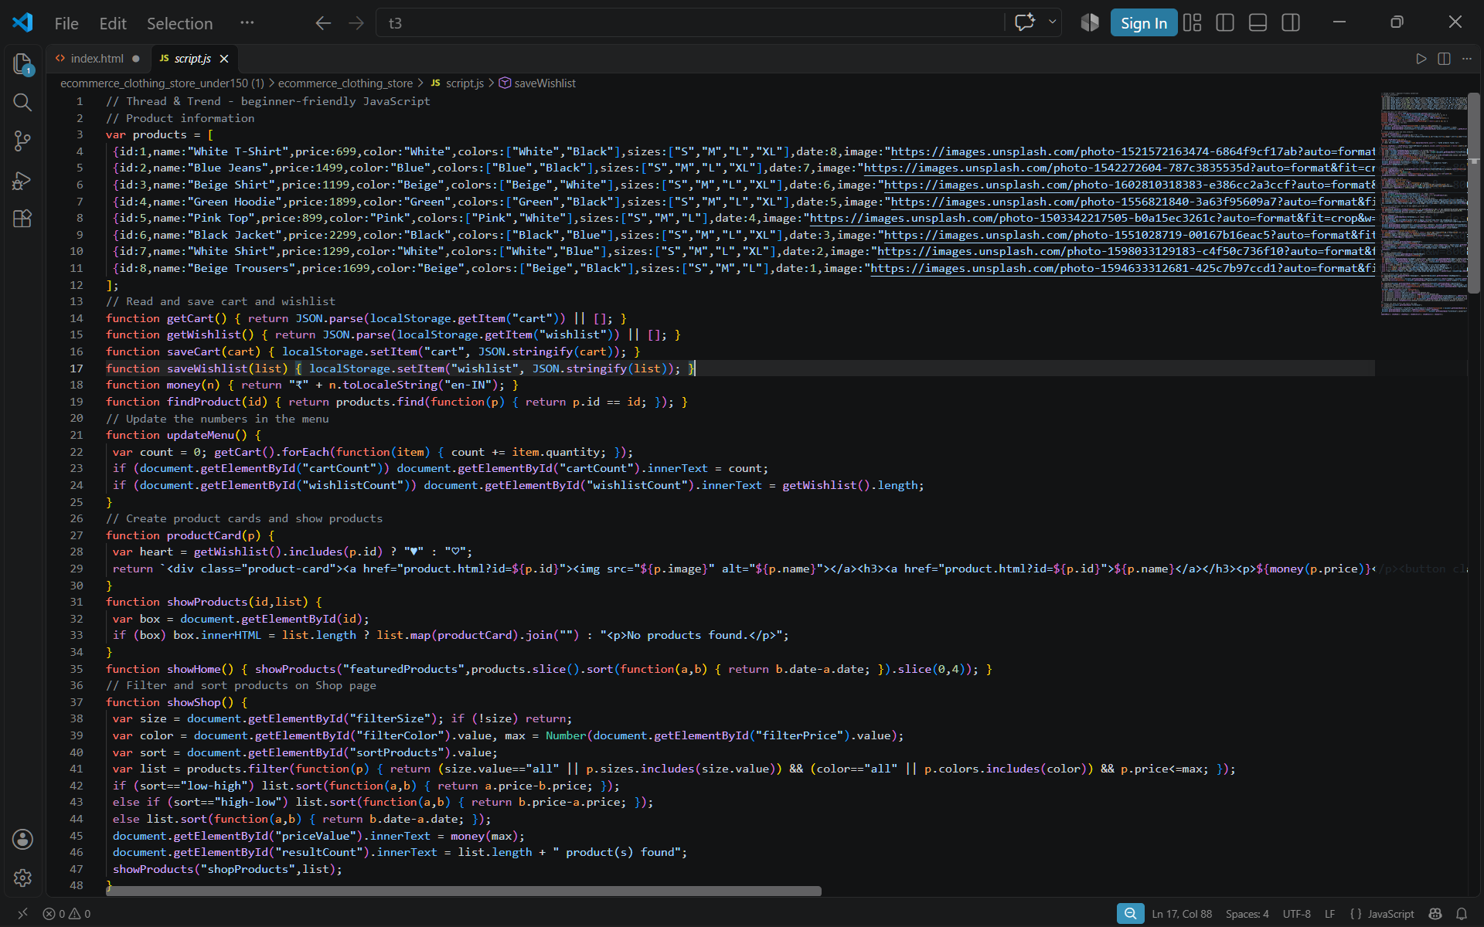
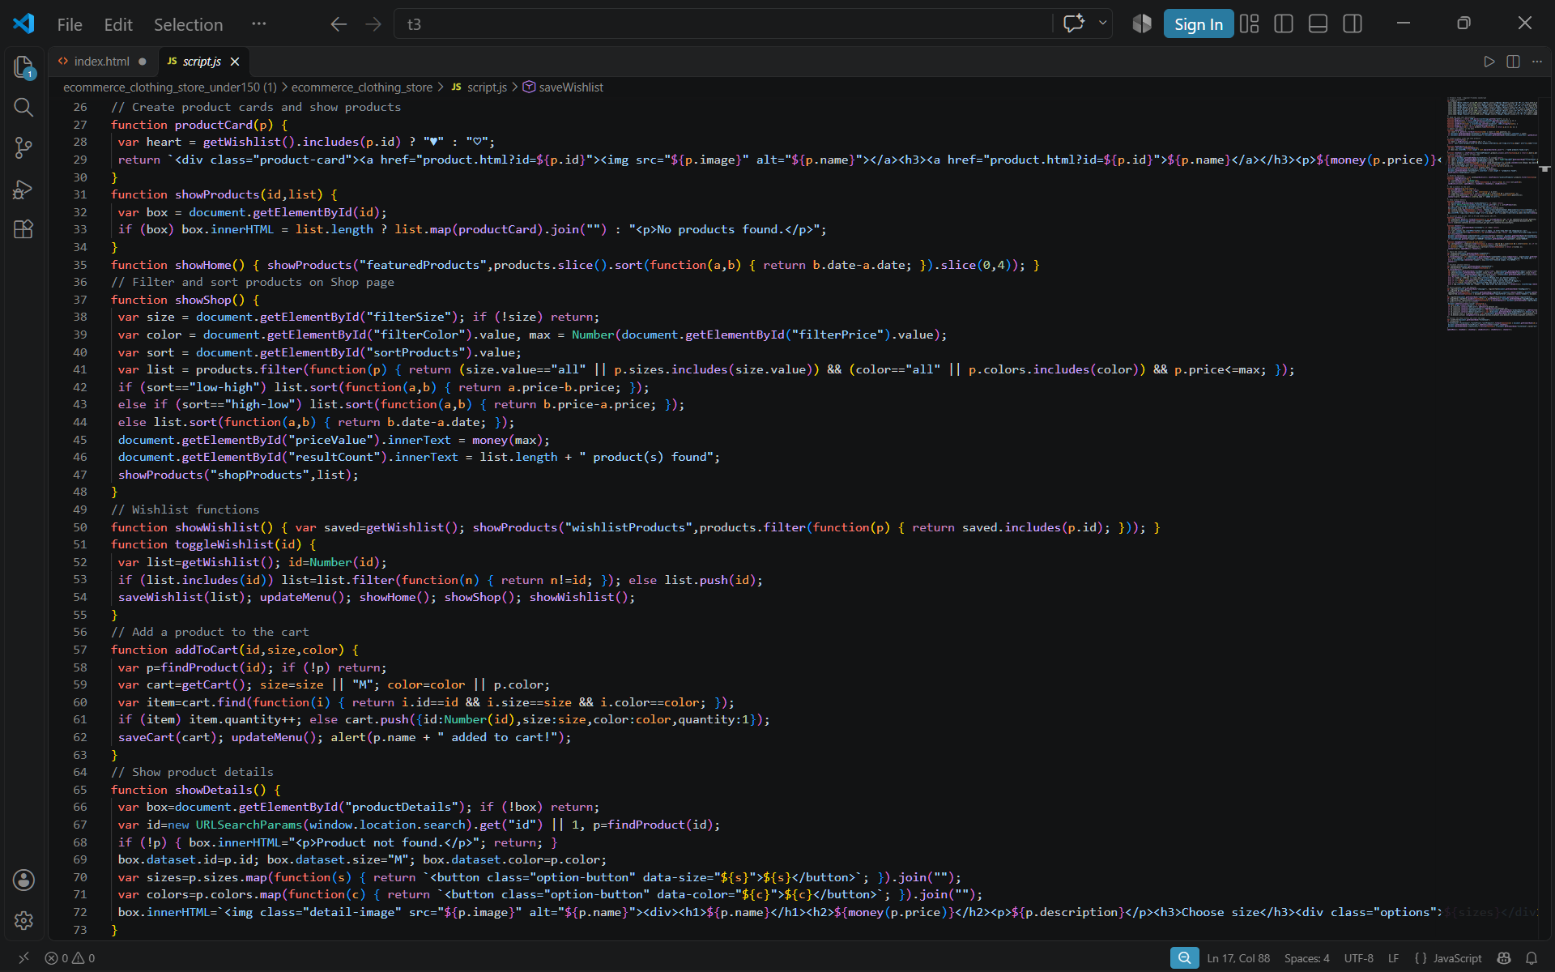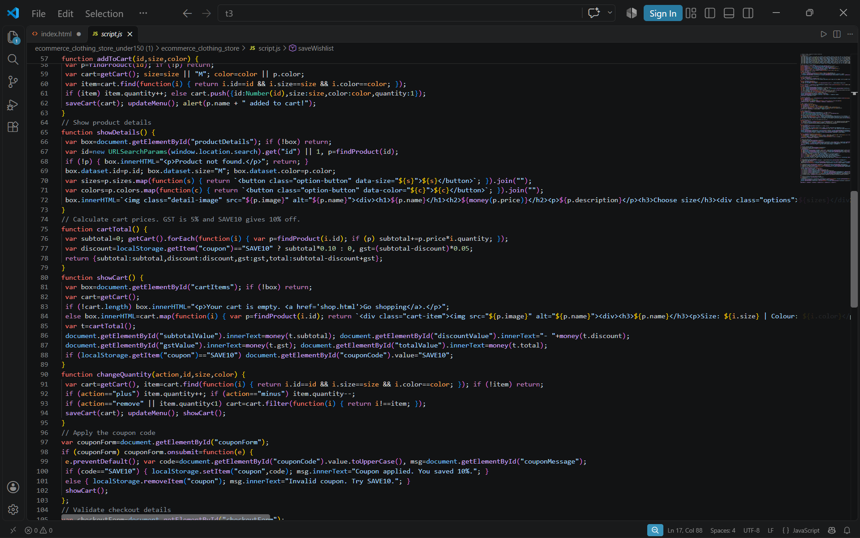
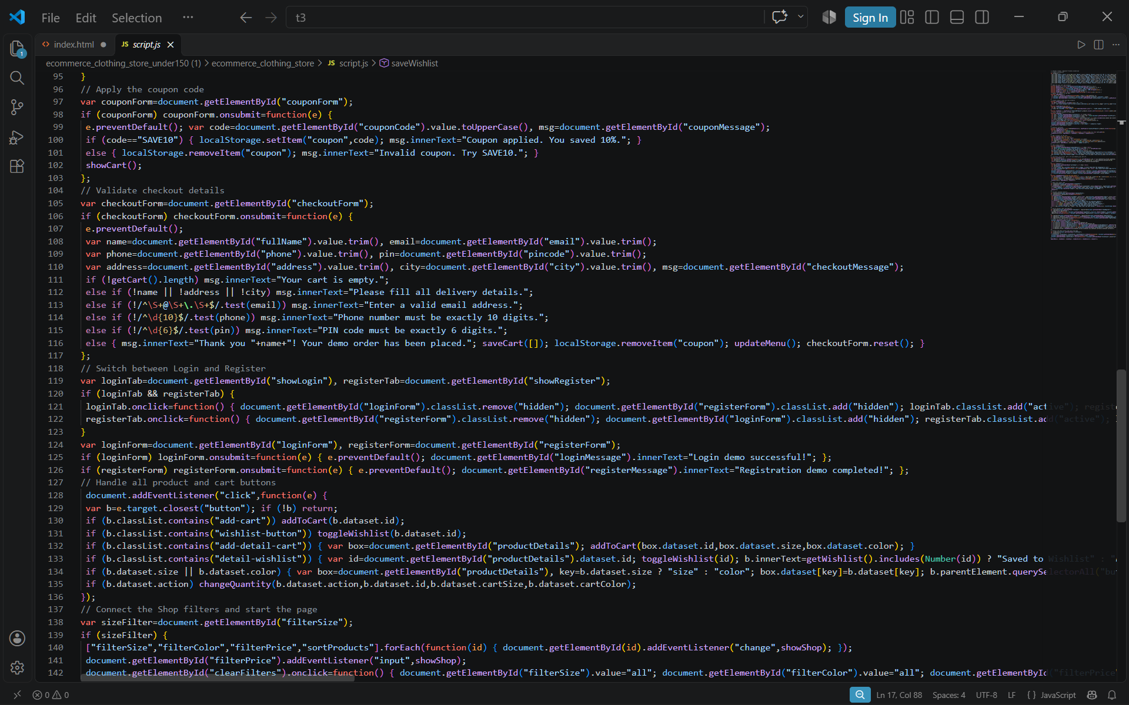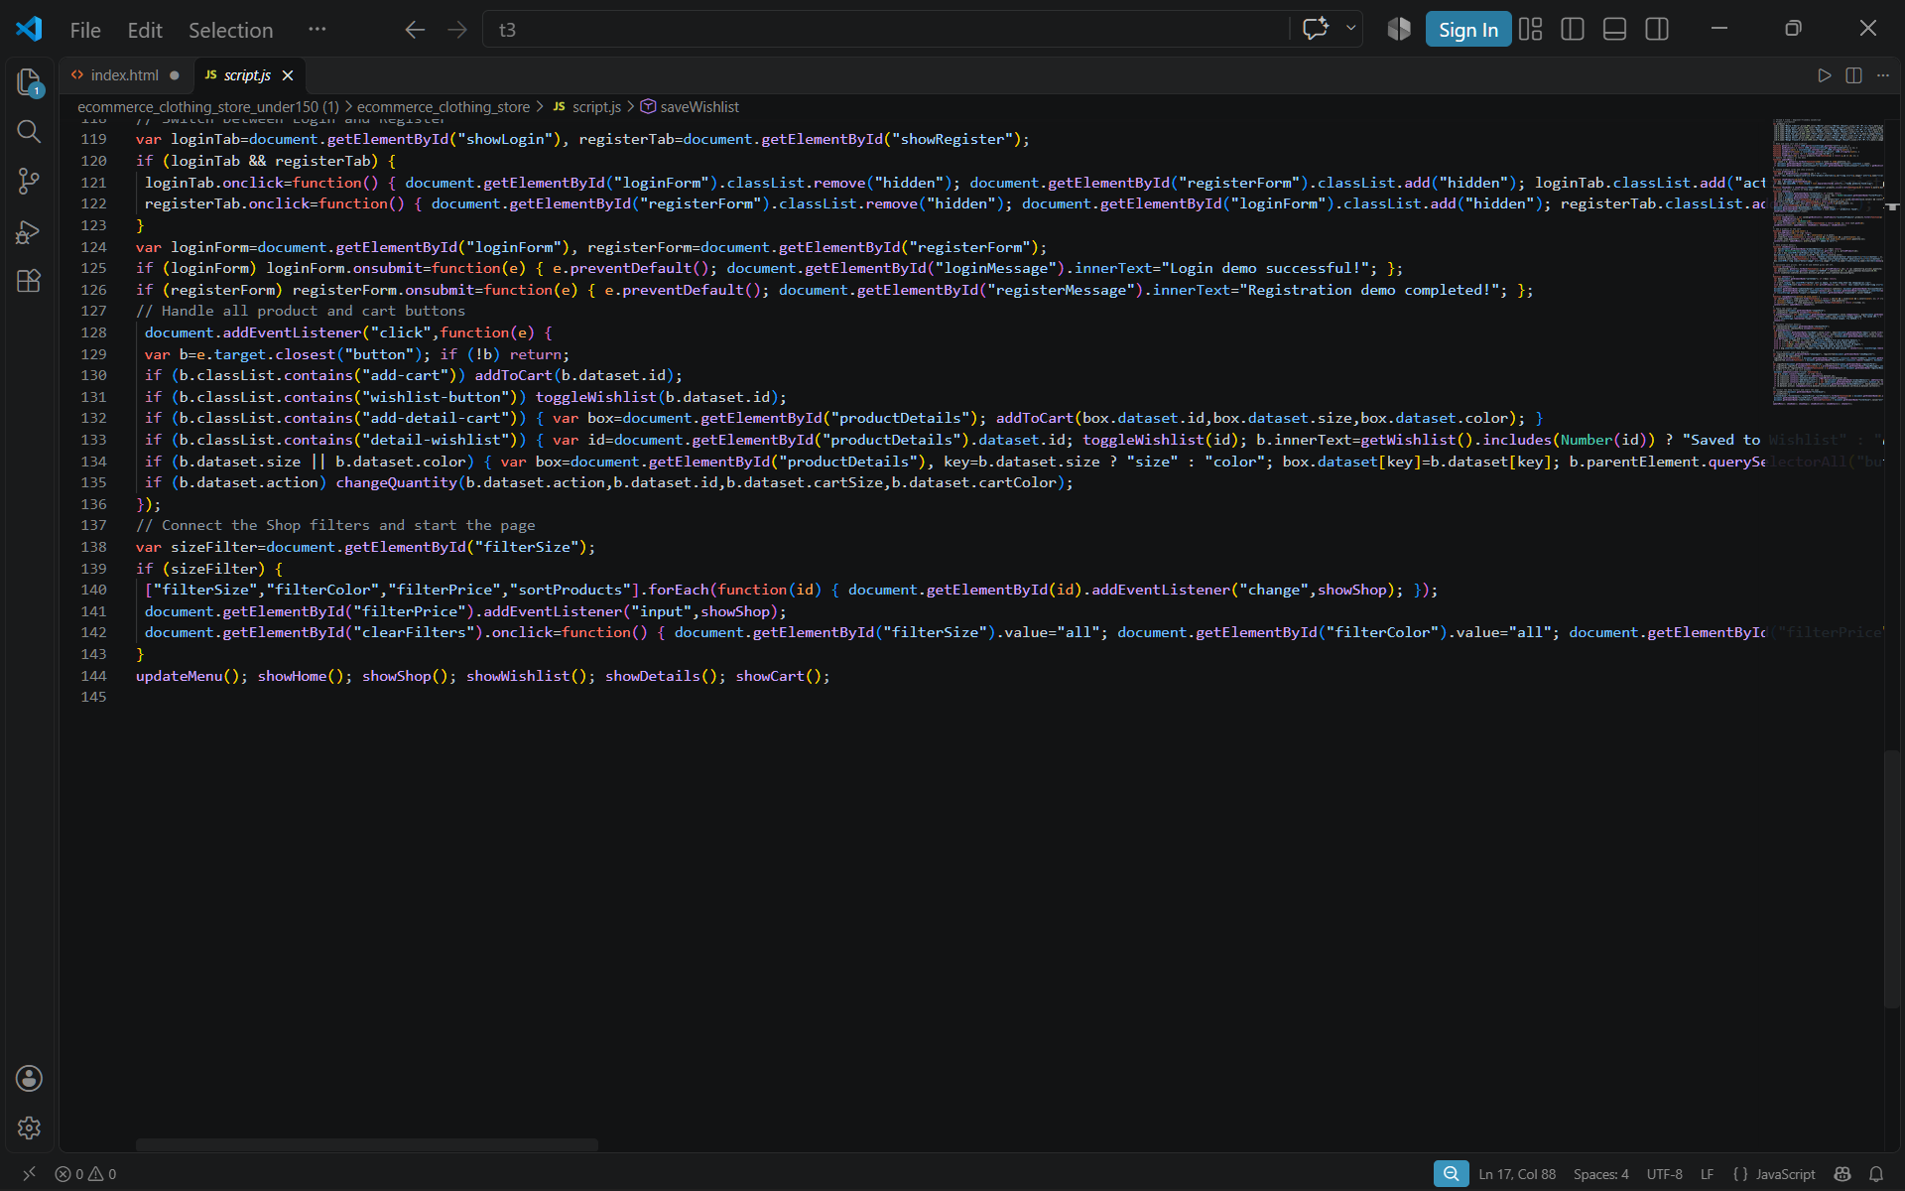
SHOP.HTML

<!DOCTYPE html>
<html lang="en">
<head>
<meta charset="UTF-8">
<meta name="viewport" content="width=device-width, initial-scale=1.0">
<title>Thread & Trend | Shop</title>
<link rel="stylesheet" href="style.css">
<script src="script.js" defer></script>
</head>
<body data-page="shop">
<header class="site-header">
<a class="logo" href="index.html">Thread<span>&</span>Trend</a>
<nav class="main-nav">
<a href="index.html">Home</a><a class="active" href="shop.html">Shop</a><a href="wishlist.html">Wishlist <span class="nav-count" id="wishlistCount">0</span></a><a href="cart.html">Cart <span class="nav-count" id="cartCount">0</span></a><a href="login.html">Login</a>
</nav>
</header>

<main class="section-wrap">
<div class="page-heading"><p class="eyebrow">THE COLLECTION</p><h1>Shop all clothing</h1><p>Find something you will feel great wearing.</p></div>
<section class="filter-panel" aria-label="Product filters">
<div class="filter-control"><label for="filterSize">Size</label><select id="filterSize"><option value="all">All sizes</option><option>XS</option><option>S</option><option>M</option><option>L</option><option>XL</option></select></div>
<div class="filter-control"><label for="filterColor">Colour</label><select id="filterColor"><option value="all">All colours</option><option>Black</option><option>White</option><option>Blue</option><option>Beige</option><option>Green</option><option>Pink</option></select></div>
<div class="filter-control"><label for="filterPrice">Maximum price: <span id="priceValue">₹4,000</span></label><input type="range" id="filterPrice" min="500" max="4000" step="100" value="4000"></div>
<div class="filter-control"><label for="sortProducts">Sort by</label><select id="sortProducts"><option value="newest">Newest</option><option value="low-high">Price: low to high</option><option value="high-low">Price: high to low</option></select></div>
<button class="button button-outline" id="clearFilters" type="button">Clear filters</button>
</section>
<p class="result-count" id="resultCount"></p>
<div class="product-grid" id="shopProducts"></div>
</main>

<footer class="site-footer"><p>© 2026 Thread & Trend. Student project demo.</p><p><a href="index.html">Home</a> · <a href="cart.html">Cart</a></p></footer>
</body>
</html>

WISHLIST.HTML

<!DOCTYPE html>
<html lang="en">
<head>
<meta charset="UTF-8">
<meta name="viewport" content="width=device-width, initial-scale=1.0">
<title>Thread & Trend | Wishlist</title>
<link rel="stylesheet" href="style.css">
<script src="script.js" defer></script>
</head>
<body data-page="wishlist">
<header class="site-header">
<a class="logo" href="index.html">Thread<span>&</span>Trend</a>
<nav class="main-nav">
<a href="index.html">Home</a><a href="shop.html">Shop</a><a class="active" href="wishlist.html">Wishlist <span class="nav-count" id="wishlistCount">0</span></a><a href="cart.html">Cart <span class="nav-count" id="cartCount">0</span></a><a href="login.html">Login</a>
</nav>
</header>

<main class="section-wrap">
<div class="page-heading"><p class="eyebrow">SAVED FOR LATER</p><h1>Your wishlist</h1><p>Your favourite pieces, all in one place.</p></div>
<div class="product-grid" id="wishlistProducts"></div>
</main>

<footer class="site-footer"><p>© 2026 Thread & Trend. Student project demo.</p><p><a href="shop.html">Continue shopping</a></p></footer>
</body>
</html>

STYLE.CSS



